**V- MODEL**

* V Model is a SDLC model where execution of process happens in a sequential manner in V Shape
* It is also known as Verification and Validation Model
* In V Model the corresponding testing phase of the development phase is planned in parallel
* In this model the verification side is also called as the Development levels and Validation side is also called as testing levels

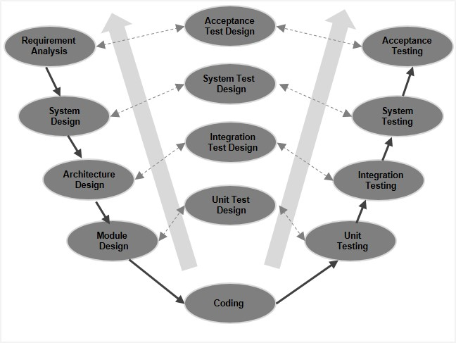

**VERIFICATION PHASE**

1. **Business Requirements:-**

* First phase of development cycle where product requirements are understood from the customer perspective.
* This phase involves the detailed communication with the customer to understand his exact requirements and expectations.
* It is very important phase need to be managed well because some of customers are not sure about their requirements about what they exactly want in their system.
* With this phase the acceptance test planning is started parallels as the gathered requirements will be the input for acceptance testing

1. **System Requirements:-**

* Once we have collected the clear and detailed product requirements, the next phase system requirements begins
* In this phase the complete system is designed to understand and analyze the overall functions of the system
* With this system design, team will figure out all required tools , hardware’s, and techniques to implement the user requirements
* System testing is planned parallel with this system design phase. Doing this at an earlier stage leaves more time for the actual test execution later

1. **Technical Specification:-**

* In this phase the system design is then broken down into the different modules called the High Level Design
* Each module is defined and understood as how each module will function and communicate with other module
* With this phase Integration testing is planned parallel

1. **Program specification:-**

* In this phase, the detailed internal design for all the system modules is specified called the low level design
* All individual module is then explained so the programmer can start coding of the module directly
* The internal design of the modules contains the detailed functional logic.
* The unit testing is planned parallel in this phase using internal module design

**Coding Phase:-**

* The best suitable programming language is decided based on the system
* In this phase developer starts the coding of designed each system modules
* The coding is performed based on the coding guidelines and standards

**VALIDATION PHASE**

1. **Unit testing:-**

* Unit testing is the testing at the code level
* Unit testing is the process where individual units of the system are tested
* This testing is done by the developer to ensure that the code meets its requirements and behave as intended
* It helps to eliminate the bugs at an early stage

1. **Integration Testing:-**

* Integration testing is the process of testing the interactions between the modules
* After system modules are developed then they are integrated to check that how they interacts with each other
* The main purpose of the integration testing is to identify the problem that arise when different components are combined and interact with each other
* It helps to identify and resolve the integration issue in early stage
* It has two methods i) Big bang integration ii) Incremental integration

1. **System Testing:-**

* It is the process of testing an integrated system
* The system testing is performed to verify that the system meets its specified requirements
* In this testing the overall functionality of the system is checked
* It is the black box testing and done by the special tester or individual tester
* There are two types of testing

1. Functional testing 2. Nonfunctional testing.

**4. Acceptance Testing:-**

- It is the last level of Testing which is performed to check the systems acceptability

- The goal of testing to establish the confidence in the system

- The testing is done to ensure that the developed system is as per user requirements and ready to deploy